
Chard Scottish Country Dance Club
Christmas Party Dance
Monday 16 December 24
Chardstock Village Hall EX13 7BJ
2£ on the door
1915 to Start dancing at 1930. Recorded music and Club Callers.
Please bring a small contribution to supper and your own mug.
Programme
J Findlay’s Jig
R Anderson’s Rant

S Orchards of Co. Armagh
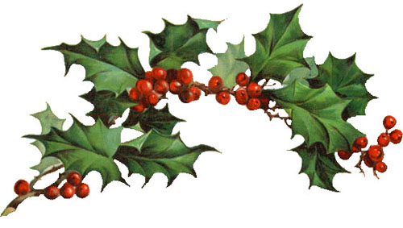
J Quarries Jig
R Falls of Rogie

Supper Interval

M Bon Viveur
J Scallywag
R Trip to Timber Ridge
J Gaelforce Wind
Spares:
R 3 Feisty Women
R Scott Meikle

